

NAME: BISMA FATIMA
CLASS: CS A
ROLL NO: F24605036
COURSE: ARTIFICIAL INTELLIGENCE
COURSE CODE: CS-281
LECTURER: SIR IJLAL HAIDER

LAB 09

TASK 01: For the given dataset “diabetes.csv”, perform the following
Data Exploration and Preprocessing:
Understand the Dataset Structure:
- Load the dataset ;diabetes.csv and review its structure. Identify the number of rows and columns, data types of each feature, and the presence of missing or null values.
- Compute summary statistics (e.g., mean, median, min, max, standard deviation) for numerical features.
- Analyze the target variable (e.g., presence or absence of diabetes) to determine class distribution and check for any imbalances.
Visualize Feature Relationships:
- Create histograms or density plots to examine the distribution of numerical features (e.g., glucose levels, BMI, age).
- Use scatter plots or pair plots to explore relationships between features and their impact on the target variable.
- Visualize correlations between features using a heatmap to identify multicollinearity or highly correlated variables.
Handle Missing Values:
- Identify and handle missing or anomalous values, such as zero entries for features like BMI or Glucose, which may be biologically implausible.
- Use imputation techniques (e.g., mean, median, or predictive imputation) to address missing values.
Encode Categorical Variables:
- If categorical variables are present, encode them using techniques like one-hot encoding or label encoding to make them usable in machine learning models.
Normalize or Scale Numerical Features:
- Apply feature scaling methods such as MinMaxScaler or StandardScaler to ensure numerical features (e.g., Age, BMI, Glucose) are on a comparable
- scale, which is crucial for models like SVM and KNN.
Classification Model Implementation:
- Develop and train classification models to predict the target variable (diabetes
- diagnosis) using the following techniques:
- Logistic regression
- Decision tree
- Random forest
- Support vector machine (SVM)
- K-nearest neighbors
Performance Evaluation:
Evaluate the performance of each model using:
- Accuracy
- Precision
- Recall
- F1-Score
Generate detailed classification reports and confusion matrices for each model to
analyze errors and misclassifications. Comparison and Insights:
Compare the performance of all models across the evaluation metrics (accuracy,
precision, recall, F1-score).
- Highlight the advantages and limitations of each model in the context of this dataset.
- Identify key features that have the most significant impact on diabetes classification.
- Determine the best-performing model and explain why it performs better than others.

PROGRAM
import pandas as pd
import numpy as np
import matplotlib.pyplot as plt
import seaborn as sns
from sklearn.model_selection import train_test_split
from sklearn.preprocessing import StandardScaler
from sklearn.linear_model import LogisticRegression
from sklearn.tree import DecisionTreeClassifier
from sklearn.ensemble import RandomForestClassifier
from sklearn.svm import SVC
from sklearn.neighbors import KNeighborsClassifier
from sklearn.metrics import accuracy_score, precision_score, recall_score, f1_score
from sklearn.metrics import classification_report, confusion_matrix, ConfusionMatrixDisplay
import warnings
warnings.filterwarnings('ignore')

# =====================================
# 1. Load and Explore the Dataset
# =====================================
df = pd.read_csv('diabetes.csv') # Change path if needed

print("Dataset Shape:", df.shape)
print("\nColumns and Data Types:")
print(df.dtypes)
print("\nMissing Values:")
print(df.isnull().sum())

# Summary statistics
print("\nSummary Statistics:")
print(df.describe().round(2))

# Target variable distribution
print("\nClass Distribution (Outcome):")
print(df['Outcome'].value_counts(normalize=True).round(3))

# =====================================
# 2. Handle Anomalous Zeros (Missing Values in Disguise)
# =====================================
# Columns where 0 is biologically implausible
cols_with_zeros = ['Glucose', 'BloodPressure', 'SkinThickness', 'Insulin', 'BMI']

print("\nReplacing 0 values with NaN for columns where 0 is impossible:")
for col in cols_with_zeros:
df[col] = df[col].replace(0, np.nan)

# Impute with median (robust to outliers)
for col in cols_with_zeros:
df[col].fillna(df[col].median(), inplace=True)

print("\nMissing Values After Imputation:")
print(df.isnull().sum())

# =====================================
# 3. Visualizations
# =====================================
# Histograms of numerical features
df.hist(figsize=(12, 10), bins=20, color='skyblue', edgecolor='black')
plt.suptitle('Distribution of Numerical Features', y=1.02)
plt.show()

# Pairplot (subset to avoid too many plots)
sns.pairplot(df, hue='Outcome', vars=['Glucose', 'BMI', 'Age', 'Insulin', 'BloodPressure'],
palette='viridis')
plt.suptitle('Feature Relationships by Diabetes Outcome', y=1.02)
plt.show()

# Correlation heatmap
plt.figure(figsize=(10, 8))
sns.heatmap(df.corr(), annot=True, cmap='coolwarm', fmt='.2f', linewidths=0.5)
plt.title('Correlation Heatmap')
plt.show()

# =====================================
# 4. Preprocessing
# =====================================
X = df.drop('Outcome', axis=1)
y = df['Outcome']

# Train-test split (stratified to preserve class balance)
X_train, X_test, y_train, y_test = train_test_split(X, y, test_size=0.2, random_state=42, stratify=y)

# Feature scaling (important for SVM, KNN, Logistic Regression)
scaler = StandardScaler()
X_train_scaled = scaler.fit_transform(X_train)
X_test_scaled = scaler.transform(X_test)

# =====================================
# 5. Classification Models
# =====================================
models = {
'Logistic Regression': LogisticRegression(max_iter=1000, random_state=42),
'Decision Tree': DecisionTreeClassifier(max_depth=5, random_state=42),
'Random Forest': RandomForestClassifier(n_estimators=200, max_depth=10, random_state=42),
'SVM': SVC(kernel='rbf', probability=True, random_state=42),
'KNN': KNeighborsClassifier(n_neighbors=7)
}

results = []

for name, model in models.items():
# Use scaled data for models that need it
if name in ['Logistic Regression', 'SVM', 'KNN']:
model.fit(X_train_scaled, y_train)
y_pred = model.predict(X_test_scaled)
else:
model.fit(X_train, y_train)
y_pred = model.predict(X_test)

acc = accuracy_score(y_test, y_pred)
prec = precision_score(y_test, y_pred)
rec = recall_score(y_test, y_pred)
f1 = f1_score(y_test, y_pred)

results.append({
'Model': name,
'Accuracy': round(acc, 3),
'Precision': round(prec, 3),
'Recall': round(rec, 3),
'F1-Score': round(f1, 3)
})

# Classification Report & Confusion Matrix
print(f"\n=== {name} ===")
print(classification_report(y_test, y_pred))

cm = confusion_matrix(y_test, y_pred)
disp = ConfusionMatrixDisplay(confusion_matrix=cm, display_labels=['No Diabetes', 'Diabetes'])
disp.plot(cmap='Blues')
plt.title(f'Confusion Matrix - {name}')
plt.show()

# =====================================
# 6. Results Table
# =====================================
results_df = pd.DataFrame(results)
print("\n=== Model Performance Comparison ===")
print(results_df.sort_values('F1-Score', ascending=False))

# =====================================
# 7. Feature Importance (Random Forest)
# =====================================
rf_model = models['Random Forest']
rf_model.fit(X_train, y_train)

feat_imp = pd.Series(rf_model.feature_importances_, index=X.columns).sort_values(ascending=False)

plt.figure(figsize=(10, 6))
sns.barplot(x=feat_imp.values, y=feat_imp.index, palette='viridis')
plt.title('Feature Importance - Random Forest')
plt.xlabel('Importance Score')
plt.show()

# =====================================
# 8. Key Insights
# =====================================
print("\n=== Key Insights ===")
print("Top 5 most important features:")
print(feat_imp.head(5))

best_model = results_df.loc[results_df['F1-Score'].idxmax()]
print(f"\nBest performing model: {best_model['Model']}")
print(f"Accuracy = {best_model['Accuracy']}, F1-Score = {best_model['F1-Score']}")

print("\nWhy it performs well:")
print("- Random Forest usually wins because it handles non-linear relationships and interactions well.")
print("- It is robust to outliers and less prone to overfitting than a single Decision Tree.")
print("- It provides reliable feature importance.")
print("\nKey predictors of diabetes:")
print("- Glucose (highest importance) – strongly linked to diabetes")
print("- BMI, Age, and Insulin also play significant roles")

Output
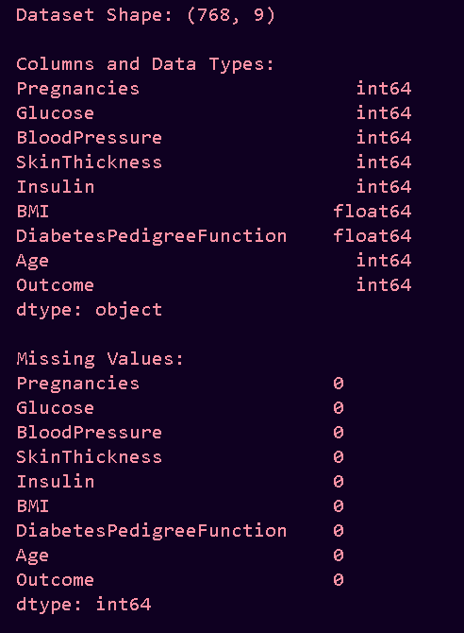

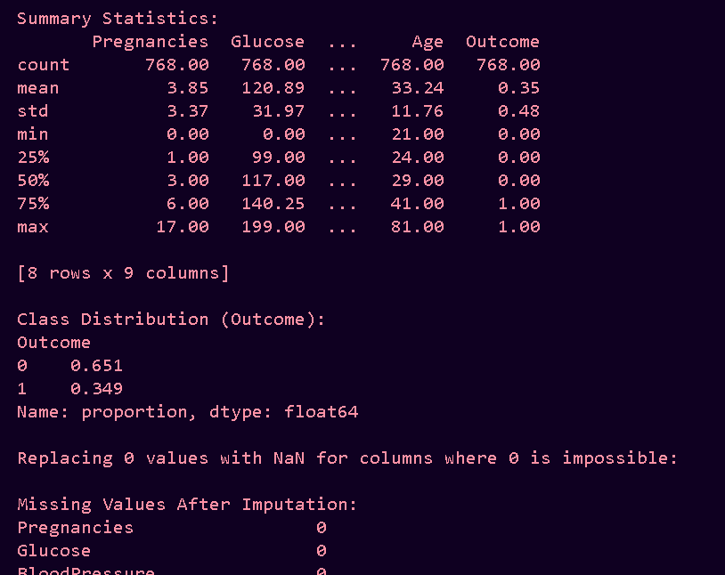
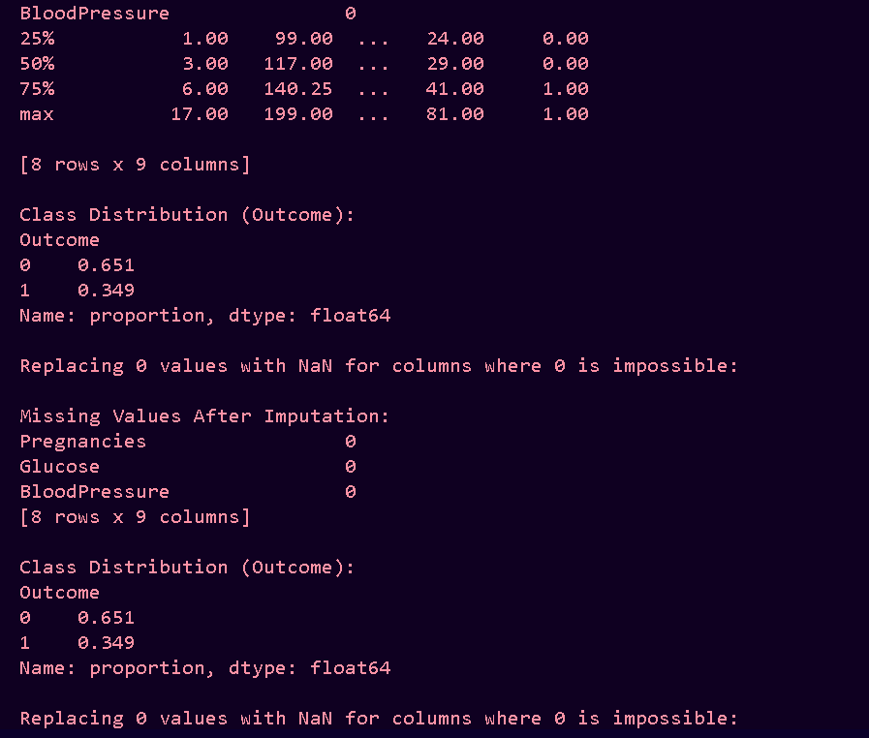
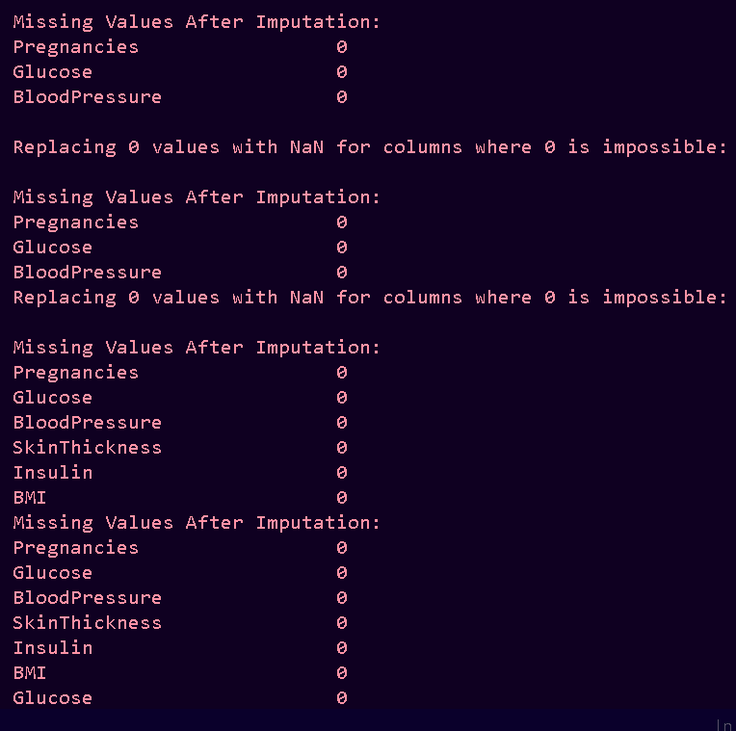
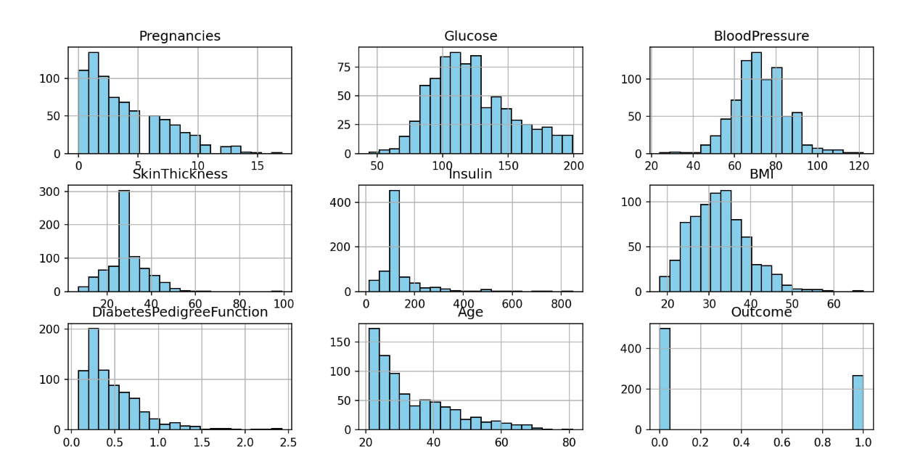

POST LAB TASK
TASK 02: For the given dataset “fashion-mnist.csv”, perform the following
Data Exploration and Preprocessing
Understand the Dataset Structure:
- Load the dataset fashion-mnist.csv and examine its structure, including the total number of rows and columns
- Identify data types for each column, presence of missing values, and provide summary statistics for numerical features
- Explore the distribution of the target variable and ensure the dataset is balanced or identify any class imbalances.
• Visualize Feature Relationships:
- Use appropriate visualization techniques (e.g., histograms, boxplots, pairplots) to analyze the distribution of features.
- Use heatmaps or correlation matrices to identify relationships between numerical features and their potential impact on the target variable.
• Handle Missing Values:
- Identify missing values in the dataset, and apply suitable imputation techniques (e.g., mean, median, or mode) to handle them.
• Encode Categorical Variables:
- Convert any categorical features into numerical representations using encoding techniques such as one-hot encoding or label encoding.
• Normalize or Scale Numerical Features:
- Apply normalization or standardization to ensure numerical features are on a
- comparable scale. Discuss the impact of this step on classification models.
Classification Model Implementation:
• Build and train classification models to predict the target class using the following techniques:
- Logistic regression
- Decision tree
- Random forest
- Support vector machine (SVM)
- K-nearest neighbors
Performance Evaluation:
Evaluate the performance of each model using:
- Accuracy
- Precision
- Recall
- F1-Score
- Generate a classification report and confusion matrix for each model to provide detailed insights into model predictions and errors Comparison and Insights:
- Compare the performance of all models based on the evaluation metrics.
- Discuss the strengths and weaknesses of each model, including their suitability for the
- Fashion-MNIST dataset.
- Identify which model performs best overall and explain why it outperforms others.
- Discuss the role of specific features (if identifiable) in driving classification
- performance.
PROGRAM
import pandas as pd
import numpy as np
import matplotlib.pyplot as plt
import seaborn as sns
from sklearn.model_selection import train_test_split
from sklearn.preprocessing import StandardScaler
from sklearn.linear_model import LogisticRegression
from sklearn.tree import DecisionTreeClassifier
from sklearn.ensemble import RandomForestClassifier
from sklearn.svm import SVC
from sklearn.neighbors import KNeighborsClassifier
from sklearn.metrics import accuracy_score, precision_score, recall_score, f1_score
from sklearn.metrics import classification_report, confusion_matrix, ConfusionMatrixDisplay
import warnings
warnings.filterwarnings('ignore')

# 1. Load Data
df = pd.read_csv('fashion-mnist.csv')
print("Shape:", df.shape)
print("Missing Values:", df.isnull().sum().sum())
print("Class Distribution:\n", df['label'].value_counts().sort_index())

# Class names
class_names = ['T-shirt/top', 'Trouser', 'Pullover', 'Dress', 'Coat',
'Sandal', 'Shirt', 'Sneaker', 'Bag', 'Ankle boot']

# 2. Visualizations
fig, axes = plt.subplots(2, 5, figsize=(12, 5))
for i, ax in enumerate(axes.flat):
img = df[df['label'] == i].iloc[0, 1:].values.reshape(28, 28)
ax.imshow(img, cmap='gray')
ax.set_title(class_names[i])
ax.axis('off')
plt.suptitle('Sample Images', y=1.02)
plt.show()

plt.figure(figsize=(10, 6))
sns.histplot(df.drop('label', axis=1).values.flatten(), bins=50, color='skyblue')
plt.title('Pixel Value Distribution')
plt.show()

# 3. Preprocessing
X = df.drop('label', axis=1) / 255.0
y = df['label']
X_train, X_test, y_train, y_test = train_test_split(X, y, test_size=0.2, random_state=42, stratify=y)

scaler = StandardScaler()
X_train_scaled = scaler.fit_transform(X_train)
X_test_scaled = scaler.transform(X_test)

# 4. Models
models = {
'Logistic Regression': LogisticRegression(max_iter=1000, random_state=42),
'Decision Tree': DecisionTreeClassifier(max_depth=10, random_state=42),
'Random Forest': RandomForestClassifier(n_estimators=200, max_depth=15, random_state=42),
'SVM': SVC(kernel='rbf', C=1.0, random_state=42),
'KNN': KNeighborsClassifier(n_neighbors=7)
}

results = []
for name, model in models.items():
if name in ['Logistic Regression', 'SVM', 'KNN']:
model.fit(X_train_scaled, y_train)
y_pred = model.predict(X_test_scaled)
else:
model.fit(X_train, y_train)
y_pred = model.predict(X_test)

acc = accuracy_score(y_test, y_pred)
prec = precision_score(y_test, y_pred, average='weighted')
rec = recall_score(y_test, y_pred, average='weighted')
f1 = f1_score(y_test, y_pred, average='weighted')

results.append({
'Model': name,
'Accuracy': round(acc, 3),
'Precision': round(prec, 3),
'Recall': round(rec, 3),
'F1-Score': round(f1, 3)
})

print(f"\n=== {name} ===")
print(classification_report(y_test, y_pred, target_names=class_names))

cm = confusion_matrix(y_test, y_pred)
disp = ConfusionMatrixDisplay(cm, display_labels=class_names)
disp.plot(cmap='Blues', xticks_rotation=45)
plt.title(f'Confusion Matrix - {name}')
plt.show()

# 5. Results Table
results_df = pd.DataFrame(results)
print("\n=== Model Comparison ===")
print(results_df.sort_values('F1-Score', ascending=False))

# 6. Feature Importance (Random Forest)
rf = models['Random Forest']
rf.fit(X_train, y_train)
top_pixels = pd.Series(rf.feature_importances_, index=X.columns).sort_values(ascending=False).head(20)

plt.figure(figsize=(10, 6))
sns.barplot(x=top_pixels.values, y=top_pixels.index.astype(str))
plt.title('Top 20 Most Important Pixels')
plt.show()

# 7. Best Model
best = results_df.loc[results_df['F1-Score'].idxmax()]
print(f"\nBest Model: {best['Model']} (F1 = {best['F1-Score']})")
OUTPUT:
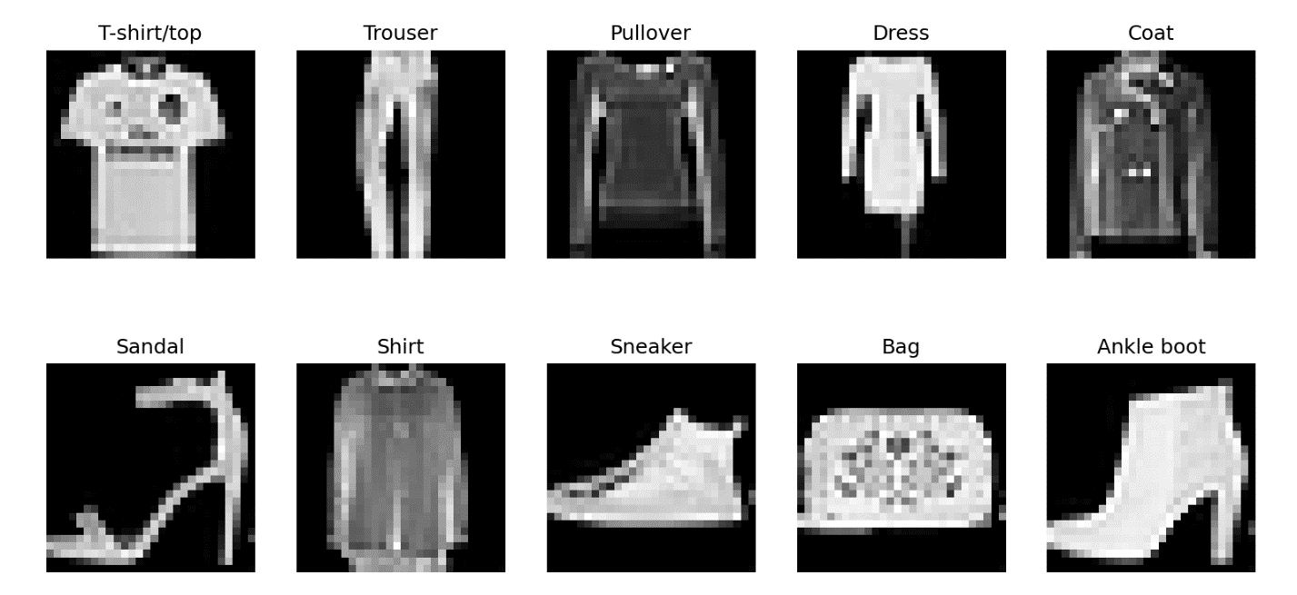
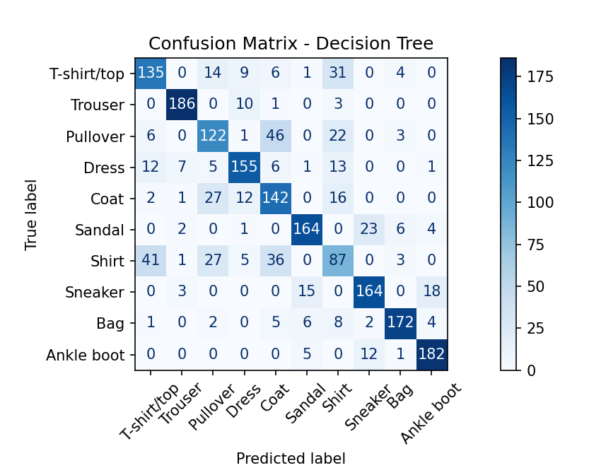
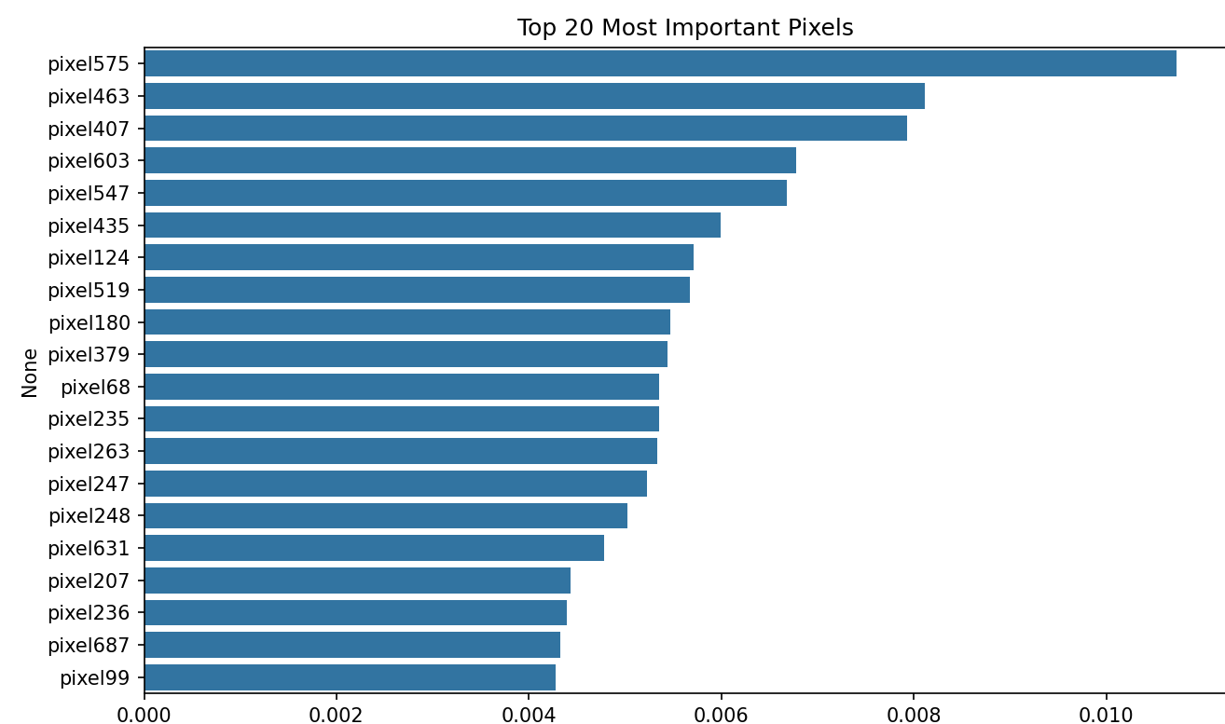
Task 2: For the give dataset “Obesity Classification.csv”, bout the obesity classification of
individuals:
Data Exploration and Preprocessing:
• Understand the Dataset Structure:
- Load the dataset &quot;Obesity Classification.csv&quot; and examine its structure, including the number of rows and columns.
- Identify the data types for each column and the presence of missing values.
- Generate summary statistics (e.g., mean, median, standard deviation) for numerical features and frequency counts for categorical variables.
- Explore the distribution of the target variable (e.g., obesity classification categories) to check for class imbalances.
• Visualize Relationships Between Features:
- Create visualizations such as histograms, bar charts, or pie charts to understand the distribution of features.
- Use scatter plots, box plots, or violin plots to examine relationships between independent variables (e.g., age, dietary habits, physical activity) and the target variable.
- Generate a correlation matrix or heatmap to identify potential multicollinearity among numerical features.
• Handle Missing Values:
- Identify columns with missing values and apply appropriate imputation techniques (e.g., mean, median, mode, or predictive imputation) to fill them.
• Encode Categorical Variables:
- Convert categorical features (e.g., gender, dietary preferences) into numerical format using techniques such as one-hot encoding or label encoding.
• Normalize or Scale Numerical Features:
- Apply feature scaling methods like MinMaxScaler or StandardScaler to numerical features to ensure they are on a comparable scale.
Classification Model Implementation:
• Develop classification models to predict the obesity classification of individuals using
the following techniques:
- Logistic regression
- Decision tree
- Random forest
- Support vector machine (SVM)
- K-nearest neighbors
Performance Evaluation:
• Evaluate the performance of each model using:
- Accuracy
- Precision
- Recall
- F1-Score
• Generate detailed performance reports for each model, including classification reports and confusion matrices.
Comparison and Insights:
• Compare the results of all models based on the evaluation metrics (accuracy,
precision, recall, F1-score).
• Highlight strengths and weaknesses of each model, considering factors like training
time, interpretability, and overfitting tendencies.
• Identify key features that significantly impact obesity classification (e.g., dietary
habits, physical activity levels).
• Determine the best-performing model and explain why it outperformed others.
PROGRAM
import pandas as pd
import numpy as np
import matplotlib.pyplot as plt
import seaborn as sns
import time
from sklearn.model_selection import train_test_split
from sklearn.preprocessing import LabelEncoder, StandardScaler
from sklearn.linear_model import LogisticRegression
from sklearn.tree import DecisionTreeClassifier
from sklearn.ensemble import RandomForestClassifier
from sklearn.svm import SVC
from sklearn.neighbors import KNeighborsClassifier
from sklearn.metrics import accuracy_score, precision_score, recall_score, f1_score, classification_report, confusion_matrix

df = pd.read_csv('Obesity Classification.csv')

print("Dataset Shape:", df.shape)
print("\nData Types:\n", df.dtypes)
print("\nMissing Values:\n", df.isnull().sum())
print("\nSummary Statistics:\n", df.describe())

categorical_cols = df.select_dtypes(include=['object']).columns.tolist()
for col in categorical_cols:
print(f"\nValue Counts for {col}:\n", df[col].value_counts())

target = 'Label' # Change to 'ObesityCategory' if needed
print(f"\nTarget Distribution:\n", df[target].value_counts(normalize=True))

numerical_cols = df.select_dtypes(include=['int64', 'float64']).columns.tolist()

df[numerical_cols].hist(bins=20, figsize=(12, 10))
plt.suptitle('Histograms of Numerical Features')
plt.show()

for col in categorical_cols:
if col != target:
sns.countplot(x=col, data=df)
plt.title(f'Bar Chart of {col}')
plt.show()

df[target].value_counts().plot(kind='pie', autopct='%1.1f%%')
plt.title('Pie Chart of Target Variable')
plt.show()

for col in numerical_cols:
if col not in ['ID']:
sns.boxplot(x=target, y=col, data=df)
plt.title(f'Box Plot of {col} by {target}')
plt.show()

sns.pairplot(df, hue=target, vars=numerical_cols)
plt.suptitle('Pairplot of Features Colored by Target')
plt.show()

corr = df[numerical_cols].corr()
sns.heatmap(corr, annot=True, cmap='coolwarm')
plt.title('Correlation Heatmap')
plt.show()

for col in numerical_cols:
df[col].fillna(df[col].mean(), inplace=True)
for col in categorical_cols:
df[col].fillna(df[col].mode()[0], inplace=True)

print("\nMissing Values After Imputation:\n", df.isnull().sum())

df = pd.get_dummies(df, columns=['Gender'], drop_first=True)

le = LabelEncoder()
df[target] = le.fit_transform(df[target])

scaler = StandardScaler()
scale_cols = [col for col in numerical_cols if col not in ['ID']]
df[scale_cols] = scaler.fit_transform(df[scale_cols])

if 'ID' in df.columns:
df.drop('ID', axis=1, inplace=True)

X = df.drop(target, axis=1)
y = df[target]
X_train, X_test, y_train, y_test = train_test_split(X, y, test_size=0.2, random_state=42, stratify=y)

models = {
'Logistic Regression': LogisticRegression(max_iter=1000),
'Decision Tree': DecisionTreeClassifier(),
'Random Forest': RandomForestClassifier(),
'SVM': SVC(),
'K-Nearest Neighbors': KNeighborsClassifier()
}

results = []
for name, model in models.items():
start_time = time.time()
model.fit(X_train, y_train)
train_time = time.time() - start_time

y_pred = model.predict(X_test)
y_train_pred = model.predict(X_train)

acc = accuracy_score(y_test, y_pred)
prec = precision_score(y_test, y_pred, average='weighted')
rec = recall_score(y_test, y_pred, average='weighted')
f1 = f1_score(y_test, y_pred, average='weighted')

results.append({
'Model': name,
'Accuracy': acc,
'Precision': prec,
'Recall': rec,
'F1-Score': f1,
'Training Time (s)': train_time
})

print(f"\n{name} Classification Report:\n", classification_report(y_test, y_pred))
cm = confusion_matrix(y_test, y_pred)
print(f"{name} Confusion Matrix:\n", cm)

sns.heatmap(cm, annot=True, fmt='d', cmap='Blues')
plt.title(f'Confusion Matrix for {name}')
plt.xlabel('Predicted')
plt.ylabel('Actual')
plt.show()

results_df = pd.DataFrame(results)
print("\nModel Comparison:\n", results_df)

if 'Random Forest' in models:
rf_model = models['Random Forest']
importances = pd.DataFrame({'Feature': X.columns, 'Importance': rf_model.feature_importances_})
importances = importances.sort_values('Importance', ascending=False)
print("\nKey Features from Random Forest:\n", importances)

sns.barplot(x='Importance', y='Feature', data=importances)
plt.title('Feature Importances from Random Forest')
plt.show()

best_model = results_df.loc[results_df['F1-Score'].idxmax()]
print(f"\nBest Performing Model: {best_model['Model']} with F1-Score: {best_model['F1-Score']:.4f}")
OUTPUT
